# **Задания**

## **Задача 1:**

### **Работа программы:**

1

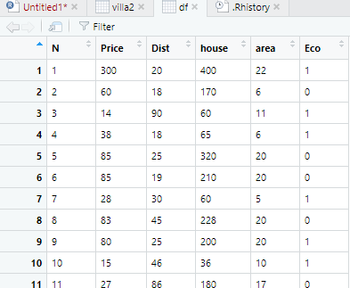

2

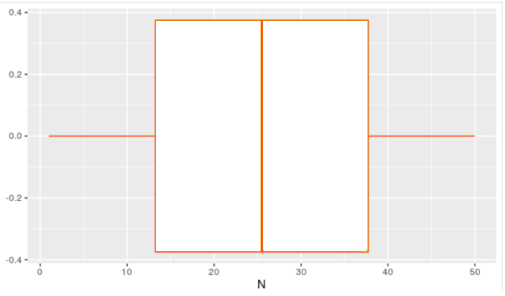

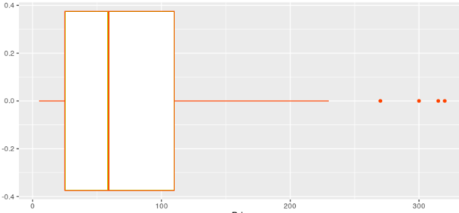

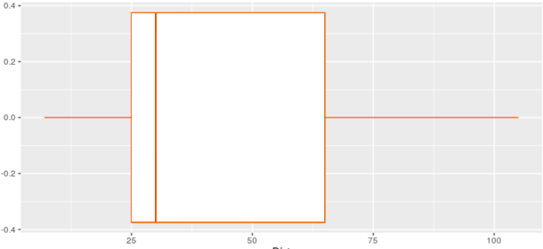

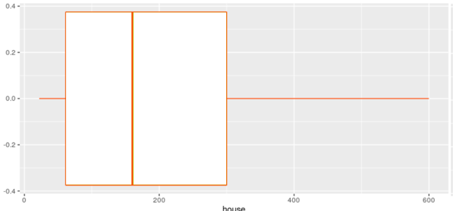

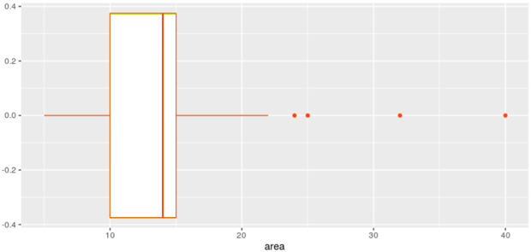

Значения выбросы присутствуют в переменных Price и Area

3

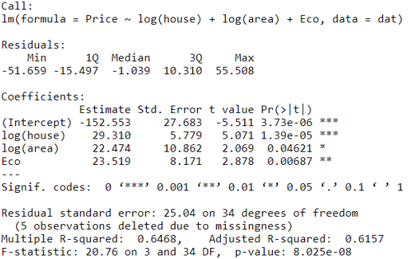

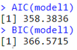

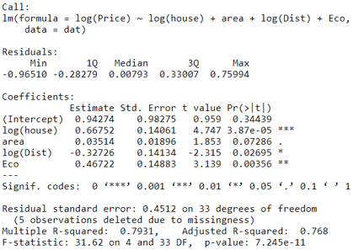

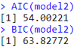

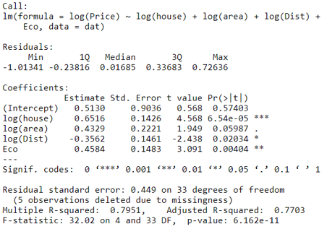

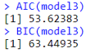

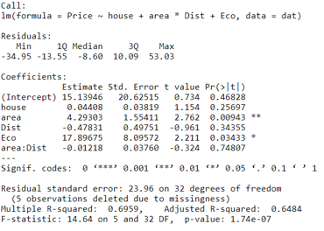

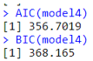

Выбираем первую модель по критериям Шварца и Акайке, тк она имеет наибольшие значения

4

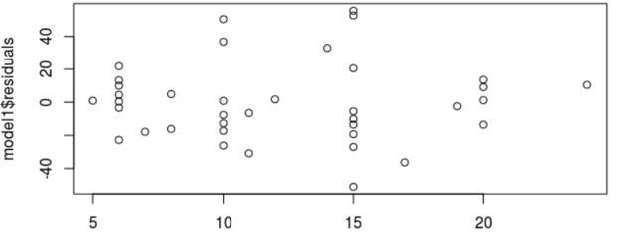

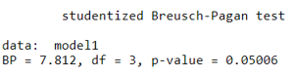

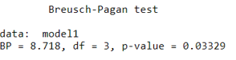

p-value < 0.05: гипотезу о гомоскедастичности отвергаем.

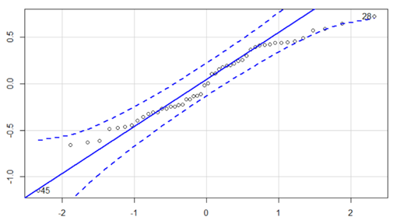



p-value > 0.05 = автокорреляция присутствует, остаточные значения имеют нормальное распределение

### **Листинг:**

df <- villa[, 1:6]

View(df)

#----------------------------------

ggplot(df, aes(x = N)) + geom_boxplot(binwidth=1, colour = "orangered", fill=" white")

ggplot(df, aes(x = Price)) + geom_boxplot(binwidth=1, colour = "orangered", fill=" white")

ggplot(df, aes(x = Dist)) + geom_boxplot(binwidth=1, colour = "orangered", fill=" white")

ggplot(df, aes(x = house)) + geom_boxplot(binwidth=1, colour = "orangered", fill=" white")

ggplot(df, aes(x = area)) + geom_boxplot(binwidth=1, colour = "orangered", fill=" white")

#----------------------------------

boxplot.stats(df$Price)$out

ind <- which(df$Price %in% boxplot.stats(dat$Price)$out)

ind

df <- df[-ind, ]

ggplot(df, aes(x = Price)) + geom_boxplot(binwidth=1, colour = "orangered", fill=" white")

#----------------------------------

boxplot(df$area)

boxplot.stats(df$area)$out

ind <- which(df$area %in% boxplot.stats(dat$area)$out)

ind

df <- df[-ind, ]

ggplot(df, aes(x = area)) + geom_boxplot(binwidth=1, colour = "orangered", fill="white")

#----------------------------------

summary(lm(formula=Price~log(house)+log(area)+Eco, data= df))

AIC(lm(formula=Price~log(house)+log(area)+Eco, data= df))

BIC(lm(formula=Price~log(house)+log(area)+Eco, data= df))

#----------------------------------

summary(lm(formula=log(Price)~log(house)+area+log(Dist)+Eco, data= df))

AIC(lm(formula=log(Price)~log(house)+area+log(Dist)+Eco, data= df))

BIC(lm(formula=log(Price)~log(house)+area+log(Dist)+Eco, data= df))

#----------------------------------

summary(lm(formula=log(Price)~log(house)+log(area)+log(Dist)+Eco, data= df))

AIC(lm(formula=log(Price)~log(house)+log(area)+log(Dist)+Eco, data= df))

BIC(lm(formula=log(Price)~log(house)+log(area)+log(Dist)+Eco, data= df))

#----------------------------------

summary(lm(formula=Price~house+area*Dist+Eco, data= df))

AIC(lm(formula=Price~house+area*Dist+Eco, data= df))

BIC(lm(formula=Price~house+area*Dist+Eco, data= df))

#----------------------------------

plot(dat$area, model1$residuals)

bptest(model1, varformula = NULL, studentize = TRUE, df)

bptest(model1, varformula = NULL, studentize = FALSE, df)

qqPlot(residuals(model1), xlab="Квантили нормального распределения", ylab="Наблюдаемые квантили")

dwt(model1)